

**CMS Smart Connectors**

**Release Notes Feb’21**

**Version: 1.0**

.



# Contents

Contents 2

1. List of connectors 3

2. What’s New 3

* ACP Level Changes.……………………………………………………………………………………………………………………………3
  + Bteq Reverse…………………………………………………………………………………………………………………………3
  + Cognos Reverse…………………………………………………………………………………………………………………….5
  + Informatica Reverse………………………………………………………………………………………………………………7
  + SAPBO Reverse………………………………………………………………………………………………………………..……8

* Jar Level Changes……………………………………………………………………………………………………………………………....10
* Cognos Reverse………………………………………………………………………………………………………………………10
* Documentation Changes…………………………………………………………………………………………………………………….10
* Cognos Reverse………………………………………………………………………………………………………………………10

# List of connectors

.

* Bteq_Reverse
* Cognos_Reverse
* Informatica_Reverse
* SAPBO_Reverse

# What’s New

* **ACP Level Changes**

**1) Bteq_Reverse:**

* **Addition of logo to the connector**

Previous:

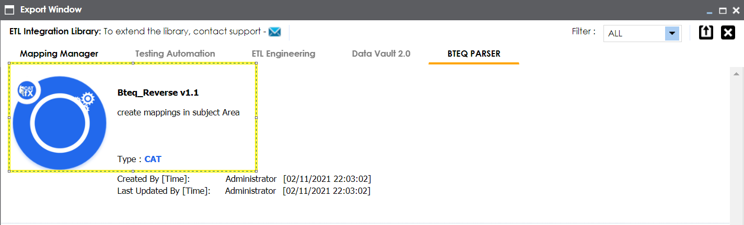

Current:

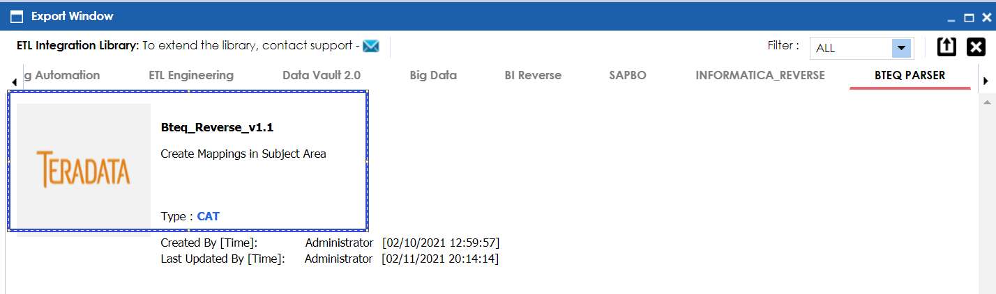

* **CAT Option label changes**

Previous:

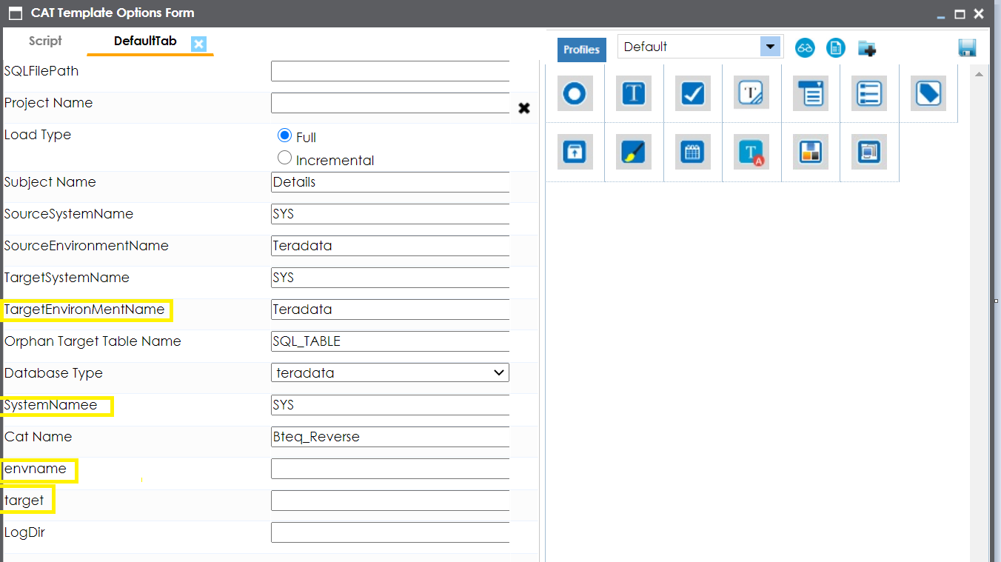

Current:

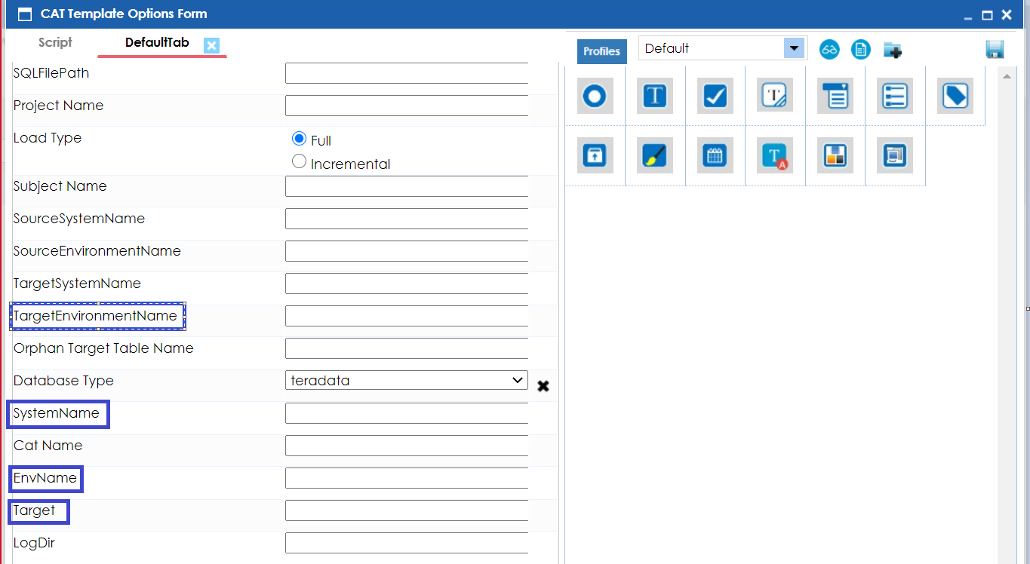

**Note:**

*We have followed the right naming standard in CAT option above.*

* **ACP Size changes**

Previous:



Current:



**Note:**

*A few cosmetic changes like CAT Option naming convention as well as logo addition.*

*As a result, the acp size got changed as shown above.*

**2) Cognos_Reverse:**

* **Addition of Description to the connector**

Previous:



Current:



* **Addition of Cat Option**

Previous:

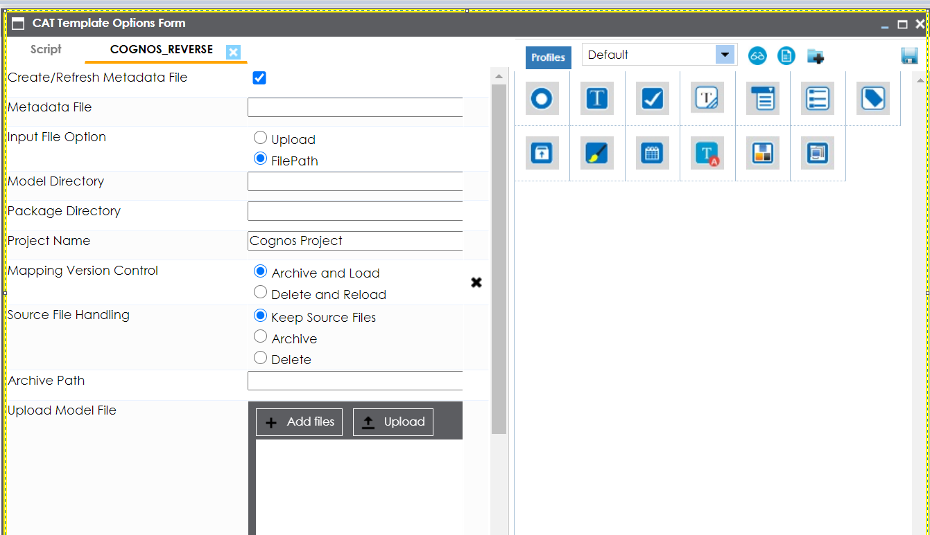

Current:

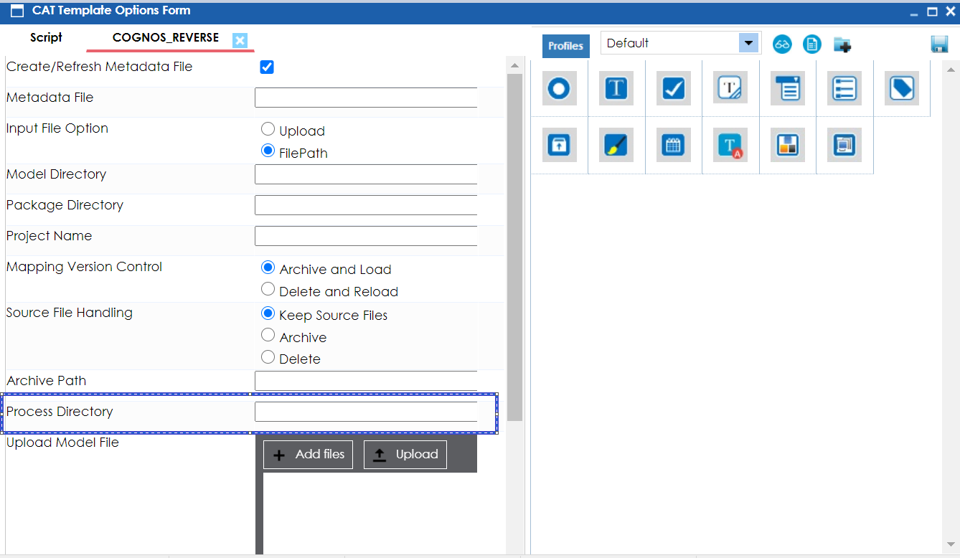

**Note:**

*This Process directory will be used by the connector to create the required temporary files during connector execution. All generated files will be deleted upon successful execution of the connector subject to proper folder permissions.*

* **ACP Size changes**

Previous:



Current:



**Note:**

*The implementation of process directory and addition of connector description increased the acp size.*

**3) Informatica_Reverse**

* **Addition of Description to the connector**

Previous:



Current:





* **CAT Option label changes**

Previous:

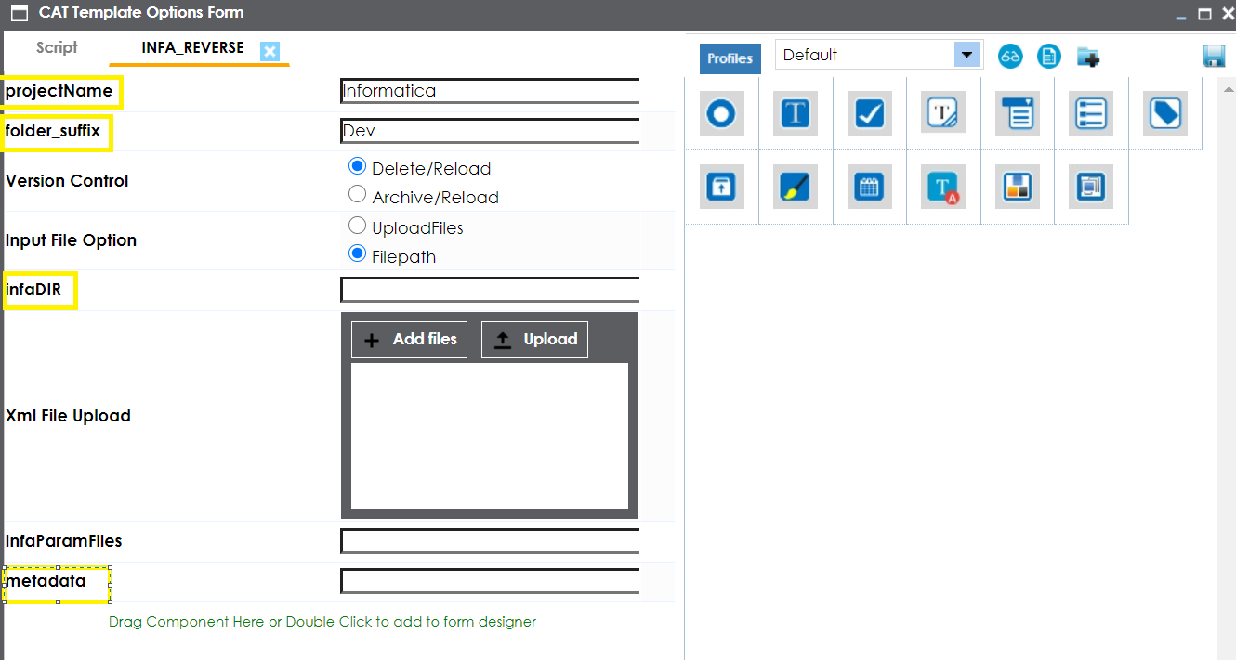

Current:

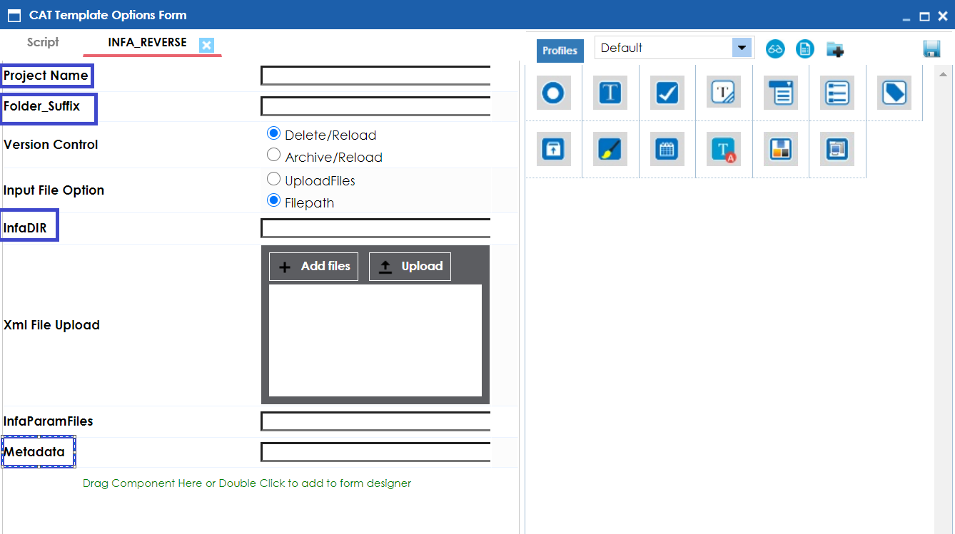

**Note:**

*We have followed the right naming standard in CAT option above.*

* **ACP Size changes**

Previous:



Current:



**Note:**

*As we have added connector description and CAT label got changed so we have small differences in size in KB. Please note in above screenshot KB changes are not reflecting as changes are minor.*

**4) SAPBO_Reverse**

* **Addition of Description to the connector**

Previous: 

Current:



* **Addition of logo to the connector**

Previous:

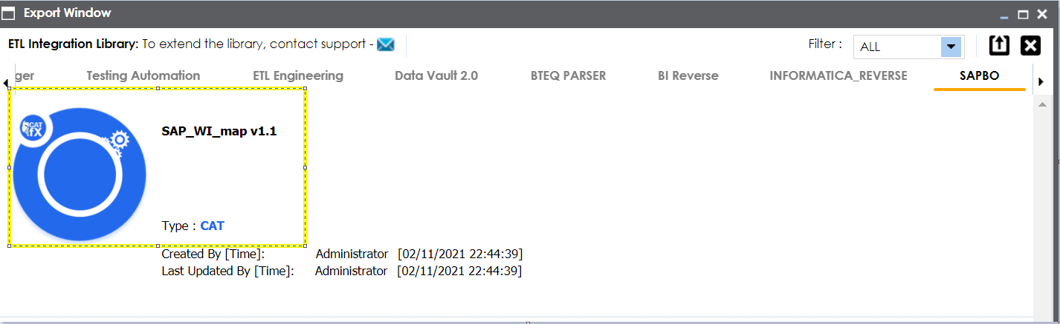

Current:

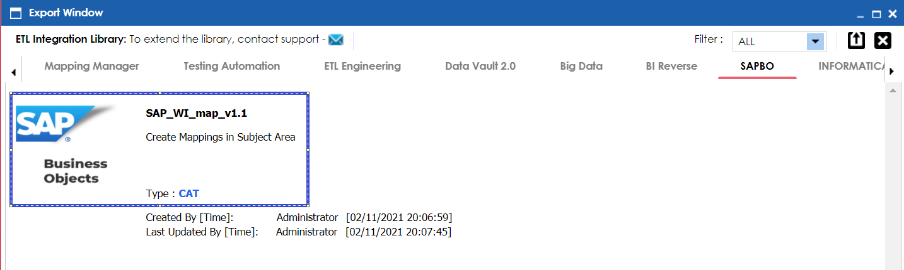

* **ACP Size changes**

Previous:



Current:



**Note:**

*Logo addition and addition of description of the connector increased the acp size above.*

* **Jar Level Changes**

**1) Cognos_Reverse**

* **Jar optimization**

Previous:



Current:



**Note:**

*Jar Optimization resulted the increase of JAR size in KB. Please note we have added process directory functionality.*

* **Documentation Changes**

**1) Cognos_Reverse**

* **Updated Cognos Reverse User Guide v1.1**

Previous:



Current:



**Note:**

*As we have added details of process directory functionality in the user guide, so size got increased.*

***\*\*\*\*\*\*\*\*\*\*\*\*\*\*\*\*\*\*\*\*\*\*\*\*\*\*\*\*\*\*\*\*\*\*\*\*\*\*\*\*\*\*\*\*\*\*\*\*\*\*\*\*Thank You\*\*\*\*\*\*\*\*\*\*\*\*\*\*\*\*\*\*\*\*\*\*\*\*\*\*\*\*\*\*\*\*\*\*\*\*\*\*\*\*\*\*\*\*\*\*\*\*\*\*\*\*\*\*\*\*\****